

ARC TECHNOLOGIES INTERN

NAME :
FURQAN AHMED

PROGRAM:

CYBER SECURITY

INTERN ID:

ARCH-2610-0881

REPORT TOPIC:

PYTHON NETWORK SNIFFER

BASIC INTRODUCTION AND KEY CONCEPTS

Introduction to Python Network Sniffer
Python network sniffer is a software-based tool used to capture, monitor, and analyze network traffic in real time. It allows security analysts and network administrators to observe how data packets travel across a network and how different communication protocols operate. By capturing packets, a network sniffer provides valuable insight into the structure of network communication, including source and destination addresses, protocol types, and data flow behavior.
In Cybersecurity, network sniffers are widely used for educational purposes, network troubleshooting, traffic analysis, and intrusion detection. Python is an ideal language for building a network sniffer because of its simplicity and the availability of powerful libraries such as Scapy, which provide low-level access to network packets.
This project focuses on developing a Python-based network sniffer that captures live network traffic and analyzes packet information to understand how data flows within a network environment. The sniffer runs continuously and allows the user to manually stop packet capturing, making it similar to real-world network monitoring tools.

Key Concepts of a Network Sniffer:

1. Network Packets
A network packet is a small unit of data transmitted over a network. Large data transmissions are divided into multiple packets to ensure efficient and reliable communication. Each packet contains control information and payload data.

2. Packet Sniffing
Packet sniffing is the process of capturing network packets as they travel through a network interface. A sniffer listens to network traffic and collects packets for analysis. This technique is commonly used in network monitoring and cybersecurity analysis.

3. IP Addresses
Every device connected to a network has an IP address. Packet sniffers analyze source and destination IP addresses to identify where the packet originates from and where it is being sent.

4. Network Protocols
Protocols define the rules for data communication. Common protocols analyzed by a network sniffer include:
- TCP (Transmission Control Protocol): Reliable, connection-oriented communication
- UDP (User Datagram Protocol): Fast, connectionless communication
- ICMP (Internet Control Message Protocol): Used for network diagnostics such as ping

5. Packet Headers
Each network packet contains headers that store important metadata such as IP addresses, protocol type, and port numbers. A sniffer analyzes packet headers to understand packet structure without accessing encrypted payload data.

6. Real-Time Traffic Analysis
Real-time analysis allows the sniffer to process packets as they are captured. This helps in understanding live network behavior and identifying abnormal or suspicious traffic patterns.

7. Ethical Use of Packet Sniffers
Packet sniffing must only be performed on authorized networks. Unauthorized packet capturing may violate privacy laws and cybersecurity regulations. This project follows ethical guidelines and is implemented strictly for educational and authorized testing purposes.

PRACTICAL WORKING OF TOOL

1 : (Python Network Sniffer Setup)

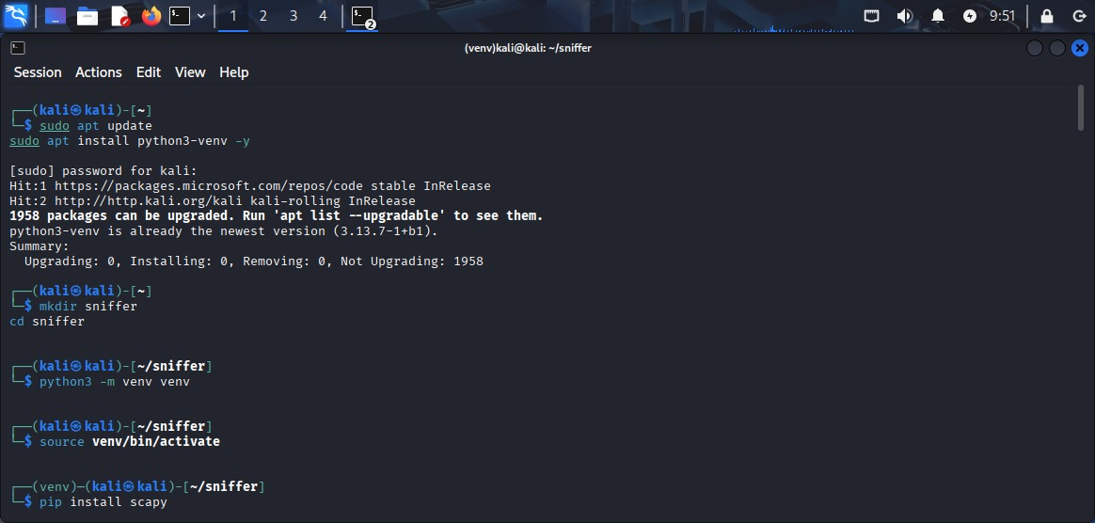

The screenshot shows the initial environment setup performed on Kali Linux to develop and execute a Python-based Network Sniffer. This setup ensures that the required tools, libraries, and isolated Python environment are properly configured before packet capturing begins.

1. System Update and Dependency Preparation

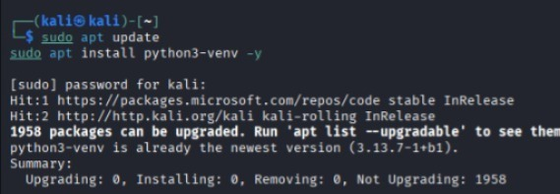
- The apt update command updates the local package index from Kali Linux repositories, ensuring access to the latest software versions.
- The python3-venv package is installed to enable the creation of Python virtual environments.
- Virtual environments are important because they allow the project to use specific Python libraries without affecting the system-wide Python installation.
This step ensures system stability and compatibility for the network sniffer project.

2. Project Directory Creation

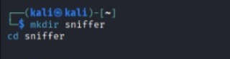
- A separate directory named sniffer is created to organize all project-related files.
- This improves maintainability and follows good software development practices by keeping the project isolated from other system files.

3. Creating a Python Virtual Environment
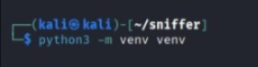
- This command creates a virtual environment named venv inside the project directory.
- The virtual environment contains its own Python interpreter and package manager.
- Using a virtual environment prevents dependency conflicts and ensures reproducibility of the project.

4. Activating the Virtual Environment
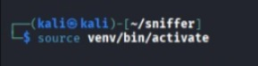
- Activating the virtual environment changes the shell prompt to indicate (venv).
- After activation, any Python packages installed will be limited to this environment only.
- This is essential for safely installing libraries like packet sniffing tools that may require elevated privileges.

5. Installing Scapy Library
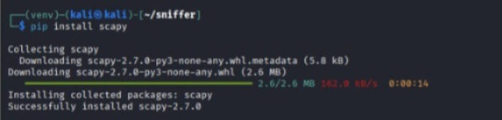
- Scapy is a powerful Python-based packet manipulation and network analysis library. It allows:

- Capturing live network packets
- Analyzing protocol headers (Ethernet, IP, TCP, UDP, ICMP)
- Crafting and sending custom packets
Scapy is widely used in ethical hacking, penetration testing, and network forensics, making it ideal for a network sniffer project.

2:(Script Preparation Phase)

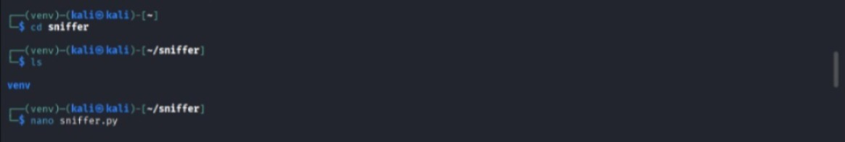
This screenshot shows the initial execution and file preparation stage of the Python Network Sniffer project in Kali Linux, after setting up the virtual environment and required libraries.

Navigating to the Project Directory

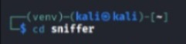
- The user navigates into the sniffer project directory where the network sniffer code and virtual environment are stored.
- Organizing project files in a dedicated directory improves readability, security, and maintainability.

Verifying Project Contents

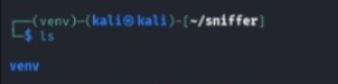
- The ls command lists the contents of the project directory.
- The output shows the presence of the venv folder, confirming that the Python virtual environment has been successfully created.
- This verification step ensures that the environment is ready before writing or executing code.

Creating the Network Sniffer Script

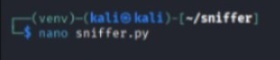
- The nano command opens a terminal-based text editor to create or edit a Python file named sniffer.py.This file will contain the core logic of the Python Network Sniffer, such as:
- Capturing network packets
- Analyzing packet headers
- Displaying protocol information (TCP, UDP, ICMP, etc.)
Using a lightweight editor like Nano is common in Linux-based penetration testing environments.

3: (Network Sniffer Code | sniffer.py)
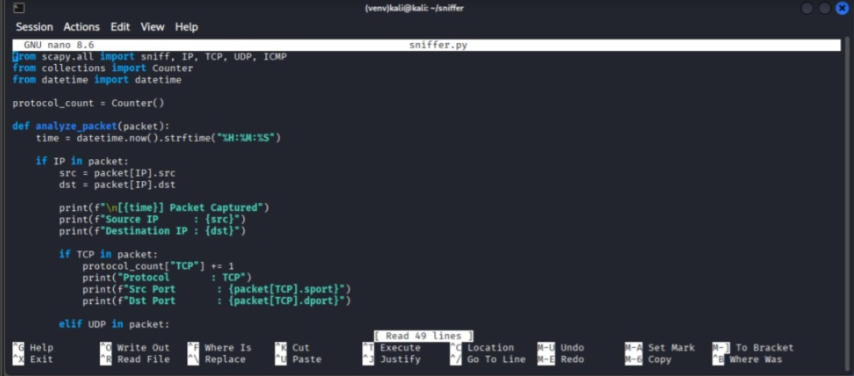

This screenshot shows the implementation of the Python-based Network Sniffer using the Scapy library. The program captures live network packets, analyzes their contents, identifies protocols, and displays relevant information such as IP addresses, port numbers, and timestamps.

1. Importing Required Libraries
Scapy is used for capturing and analyzing network packets at different protocol layers.
sniff captures live packets from the network interface.
IP, TCP, UDP, and ICMP represent different protocol layers used to inspect packet contents.
Counter is used to maintain a count of different protocols captured during sniffing.
datetime is used to timestamp each captured packet.

2. Protocol Counter Initialization
- This variable tracks how many packets belong to each protocol (TCP, UDP, ICMP).
- Protocol statistics are useful for analyzing traffic patterns and network behavior.

3. Packet Analysis Function
- This function is automatically called for every captured packet.
- It extracts and displays meaningful information from each packet.

4. Timestamp Generation
- Records the exact time at which the packet was captured.
- Time-based analysis helps in network monitoring and forensic investigations.

5. IP Layer Analysis
- Checks whether the packet contains an IP layer.
- Extracts the source IP address and destination IP address.
- This information identifies the communicating hosts on the network.

6. Packet Capture Notification
- Displays a formatted output indicating that a packet has been successfully captured.
- Makes the output readable and suitable for monitoring in real time.

7. TCP Packet Analysis
- Detects TCP packets and increments the TCP count.
- Displays source and destination port numbers.
- TCP analysis is important for understanding web traffic, file transfers, and secure communications.

8. UDP Packet Analysis
- Identifies UDP packets, which are commonly used in DNS, streaming, and VoIP.
- UDP packets are connectionless and handled differently from TCP.

9. ICMP Packet Analysis
- ICMP packets are used for error messages and network diagnostics (e.g., ping).
- Monitoring ICMP traffic helps detect network issues and scanning activities.

4:(Network Sniffer Execution and Output)

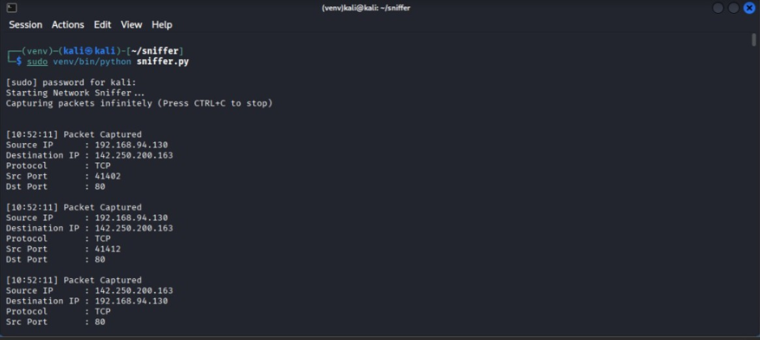
This screenshot illustrates the execution phase of the Python Network Sniffer on Kali Linux and displays the real-time packet capture output. The sniffer is executed with administrative privileges to allow access to the network interface.

1. Executing the Network Sniffer with Root Privileges
- Packet sniffing requires root (sudo) privileges because it involves direct access to network interfaces.
- The Python interpreter inside the virtual environment is explicitly used to ensure correct dependency handling.
- This command successfully starts the network sniffer application.

2. Initialization Messages
- A safe packet capture limit is applied to prevent excessive data capture and resource overuse
- These messages confirm that the sniffer has started successfully.

3. Real-Time Packet Capture
- Each captured packet is timestamped, indicating the exact time of capture.
- Time-based logging helps in traffic analysis and network troubleshooting.

4. Continuous Packet Monitoring
- Multiple ICMP packets are captured sequentially.
- This demonstrates the sniffer’s ability to monitor live network communication in real time.
- The bidirectional traffic confirms that the sniffer is correctly analyzing both outgoing and incoming packets.

5:(ICMP Traffic Generation Using Ping)

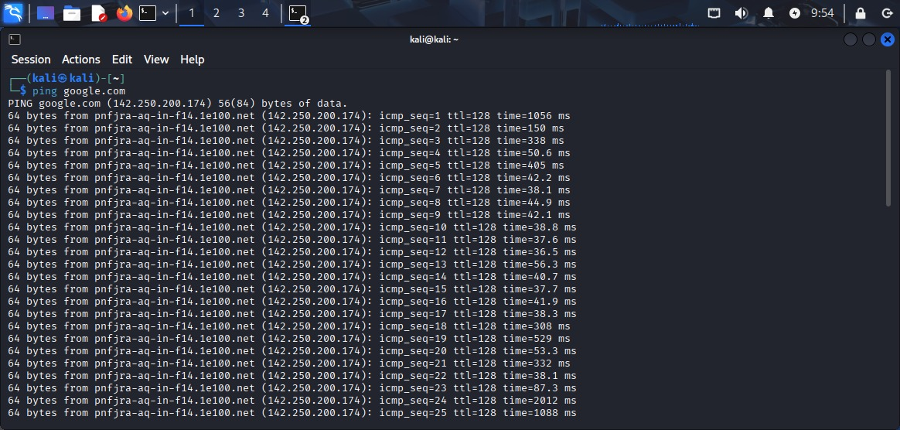

This screenshot shows the use of the ping command to generate real network traffic so that the Python-based network sniffer can capture and analyze packets in real time.
In network sniffing projects, traffic must exist on the network; otherwise, the sniffer will have nothing to capture. ICMP traffic is commonly used for this purpose because it is simple, predictable, and easy to analyze.

Command Used
ping google.com
This command sends ICMP Echo Request packets from the local machine (Kali Linux) to Google’s server and receives ICMP Echo Reply packets in response.

3. Protocol Involved: ICMP
ICMP (Internet Control Message Protocol) operates at the Network Layer (Layer 3) of the OSI model.
It is mainly used for:
- Network connectivity testing
- Error reporting
- Network diagnostics
In this case, ICMP is used to verify whether the remote host is reachable.

Role in Overall Project Workflow
This step represents:
- Traffic generation
- Packet transmission over the network
- Packet capture by the Python sniffer
- Protocol analysis and logging
It confirms that the network environment is active and ready for sniffing.

6:(Network Sniffer Output)

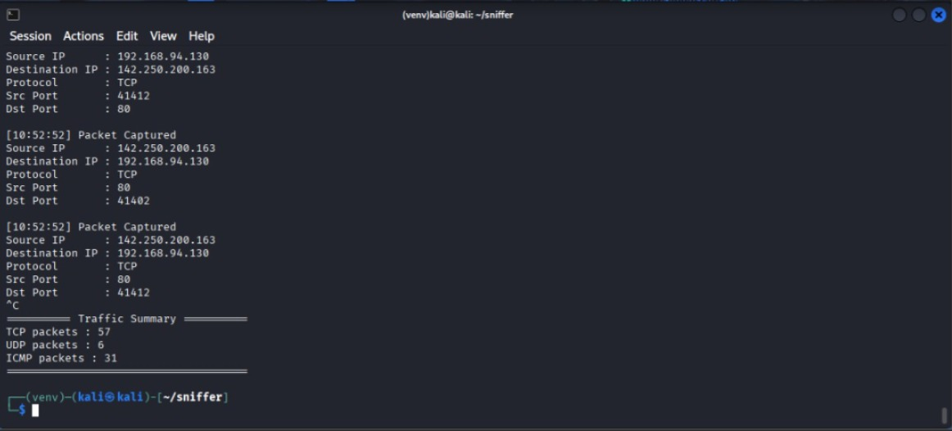
This screenshot represents the output of of the network sniffer tool after using ping command and Firefox in another terminal

1. Packet Capturing Concept
A network sniffer is a tool used to monitor and capture network packets that are transmitted over a network interface. In Python, this is usually implemented using raw sockets or packet manipulation libraries. The sniffer listens to the network interface in promiscuous mode, allowing it to capture packets not only addressed to the host but all passing traffic.

2. Source IP and Destination IP
- Source IP represents the IP address of the device that originated the packet.
- Destination IP represents the IP address of the device that receives the packet.
In the screenshot:
- 192.168.94.130 is a private IP address, indicating the local machine (client).
- 142.250.200.163 is a public IP address, typically belonging to an external server on the internet.
This shows communication between a local system and a remote web server.

3. Protocol Identification
The sniffer identifies the transport-layer protocol used by the packet:
- TCP (Transmission Control Protocol)
A reliable, connection-oriented protocol used for web traffic, file transfers, and emails.
- UDP (User Datagram Protocol)
A fast, connectionless protocol used for streaming, DNS, and VoIP.
- ICMP (Internet Control Message Protocol)
Used for error reporting and network diagnostics (e.g., ping).
The output confirms that the sniffer correctly parses and classifies packets, mainly detecting TCP traffic.

4. Source Port and Destination Port
Ports identify specific services or applications involved in communication:
- Source Port: A dynamically assigned port used by the client.
- Destination Port: A well-known or service port.
From the screenshot:
- Port 80 → Indicates HTTP traffic
- High-numbered ports (e.g., 41412) → Temporary client-side ports
This confirms that the captured packets belong to web communication sessions.

5. Packet Capture Timestamps
Each packet is logged with a timestamp, showing the exact time it was captured. This is useful for:
- Traffic analysis
- Debugging
- Forensic investigations
It proves that the sniffer works in real-time packet monitoring mode.

6. Bidirectional Communication
shows packets:
- From client → server
- From server → client
This indicates a two-way TCP connection, which is a core feature of TCP-based communication.

7. Traffic Summary Section
The traffic summary provides a statistical overview of captured packets:
- TCP packets: 57
- UDP packets: 6
- ICMP packets: 31
This helps in:
- Understanding network behavior
- Identifying dominant protocols
- Performing traffic analysis
The summary confirms that the Python sniffer successfully counts and categorizes packets based on protocol type.

8. Importance in Cybersecurity
Such a network sniffer is widely used in:
- Network monitoring
- Intrusion detection
- Traffic analysis
- Learning how protocols work internally
This project demonstrates a practical understanding of network layers, protocols, and packet structure.

[Conclusion (Report)]
The displayed output verifies that the Python-based network sniffer effectively captures live network traffic, extracts essential packet details, and provides protocol-level analysis. This demonstrates the correct implementation of packet sniffing techniques and a strong understanding of computer networking fundamentals.
Bottom of Form

